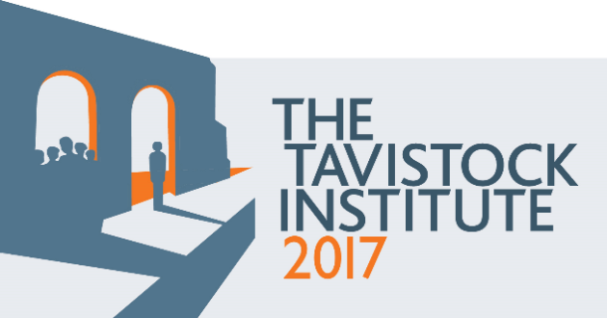

Reimagining Human Relations in our Time: Submission Form

Your name(s)
Title:
Your background, biography(s) A short summary of who you are and where you are coming from (also geographically); what brings you to the festival; your credentials in delivering your proposed activity. (100 to 200 words depending on who is involved)
Your response
This is the main space for you to describe what you would like to do; what the task of your proposed activity is. Here you need to 1) consider the main aims of the festival; 2) hold in mind that the festival will be a public event; 3) outline how learning opportunities will be embedded in your activity and 4) any expected audience you would like to reach. (250 words)
Theme please outline here which theme(s) your proposal is responding to and why. (100 words)
What form of activity are you proposing? Please say something about the type of activity you are proposing, what it is, why you have chosen this format. We are committed to curating a diverse programme that means different types of activities; different disciplinary responses. (100 words)
Overall summary of the proposal
This is as it would appear in the festival programme. Please include you title, names of those leading the activity and their biographies, a short paragraph description (200 words max.)
Requirements of the activity any restrictions on numbers of people you’d like to attend; equipment; time needed/desired for the activity; type of space.
The Tavistock Institute has already identified and confirmed a couple of venues for the festival, that it believes will support a number of different types of activities, talks, workshops, performances, exhibits. It is useful to know a bit about how you envisage your event as we may identify further spaces. (100 words max.)

For information and context on the archive project you can read further on the blog here. If you are interested in accessing the archive material the catalogue is available at the Wellcome Library here. Please note the cataloguing is ongoing and access is only possible through the catalogue i.e. we cannot facilitate access to as yet uncatalogued material.

